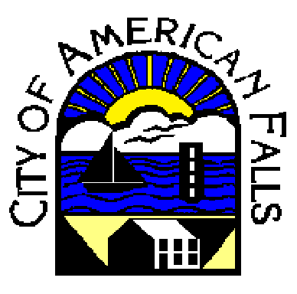

Sewer Flushing Program
The City of American Falls has roughly 30 miles of sewer line and is strives to clean the entire city every year. The goal of this program is to ensure that the sewer pipes and vaults are free from obstructions that might have a potential of creating a blockage. A high pressure nozzle is fed up the sewer pipe from one vault to another. The line with the nozzle is brought back to the combination truck, dragging debris with it. Large amounts of debris are sucked into the truck using the vacuum. A notice will go out prior to flushing. The following questions are frequently asked by many of our customers.
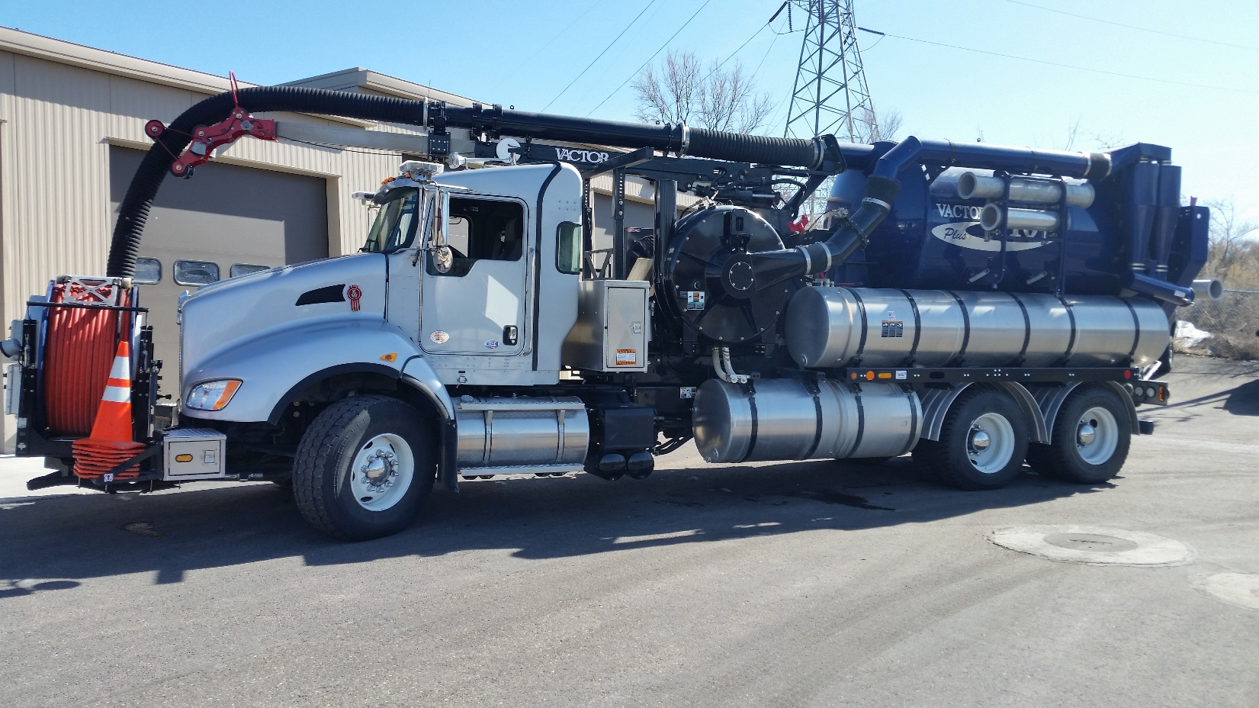

Why are we flushing?
Flushing the sewer system decreases the likelihood of a major blockage. Wastewater typically is moving through the underground pipes at about 2-3 feet per second. This movement might be slowed down due to slight changes in elevation in the pipe. Debris will collect in an area that does not have the 2-3 feet per second velocity. Minor pipe defects such as bellies and offset joints contribute to the collection of debris. Tree roots penetrating into the pipes add to the blockage problem. The city does a video inspection of one section of sewer lines per year. This tell us how effective flushing has been and shows the conditions of lines. Below is a photograph of a sewer pipe with debris that has settled.
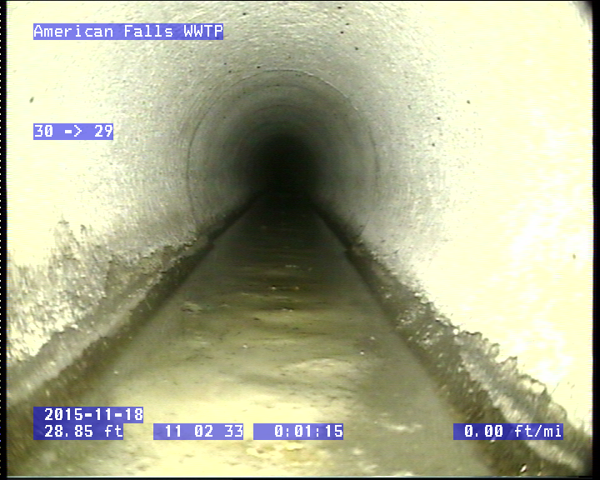

How will I be affected?
You might want to leave your toilet seat down and cover any floor drains as we clean the sewer. There is a possibility of a small amount of water “burping” out as we flush.

Please help us
Please be mindful of what you flush and put down the drains. Rags, pieces of cloth, wipes and other objects get caught in sewer pipes causing blockages and backups.
Grease is a big problem in our sewer lines. It coats the pipes creating blocks. The photograph below shows how grease can clog a pipe.
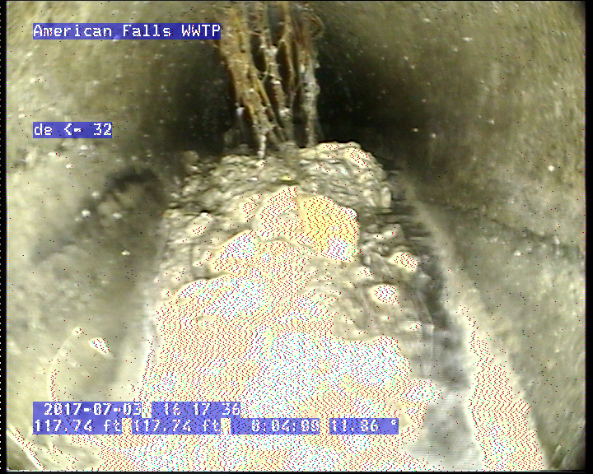

Please see the section on FOG (Fats, Oils, & Grease) for more information.

