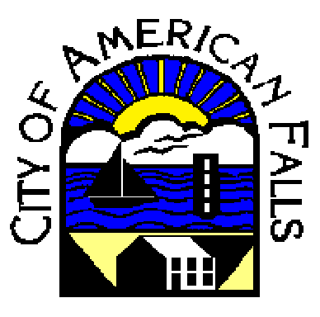

Fire Hydrant Flushing Program
Each year the Water/Wastewater Department begins its comprehensive flushing program throughout the City. The goal of this program is to ensure that the drinking water quality is at its optimal level and to properly maintain the City’s water distribution lines. This ensures the proper operation of the fire hydrants as well. Flushing is a process by which water is moved through a water pipe at a high velocity so that a scouring action is created. Water is then discharged through a hydrant which in turn removes any material build-up from the pipe. The material removed from this process is harmless and requires no special treatment. Use of this flushing technique is critical to the proper maintenance of water quality and the City’s water system. The following questions are frequently asked by many of our customers.

Why are we flushing?
Water typically is moving through the underground pipes at less than 5 feet per second. This slow movement allows mineral deposits, to build up and accumulate in pipes over time. The buildup can restrict water flow in the pipes and contributes to corrosion and water color problems. Periodic flushing of water pipes removes the mineral deposits which helps maintain our City's infrastructure and assures consistent high quality water.
This annual program also allows for identification of any inefficiency through the water system, such as closed valves and weak flows in the water mains. Flushing ensures that all fire hydrants are in proper operating condition.

How will I be affected?
You might not even be aware that hydrant flushing is taking place in your neighborhood because water service will not be interrupted. However, there may be a temporary drop in water pressure. We recommend that you avoid running tap water, dishwasher or washing machines if you see crews flushing a hydrant on your street, as it may draw unwanted sediment or discolored water into your household plumbing.
It is virtually impossible to flush off all of the sediment in a pipe. When you open your taps following a flush in your neighborhood, you may notice that your water has a colored and/or has a cloudy appearance. Discolored water poses no health risk; this is typically from the mineral deposits in the pipes that have not had time to settle. It will clear up within a few hours on its own or you can run your cold water faucet for a few minutes until the water runs clear, which flushes out the pipes in your home. If you run your hot water before discovering the problem, you may want to flush your hot water tank by opening the valve at the bottom of the tank.

Is flushing a waste of water?
It almost seems counterintuitive to waste water by flushing fire hydrants. However, it is necessary to periodically flush water through the main lines in order to protect the quality of your drinking water. The amount and cost of water used in flushing is a small price compared to the benefits of water quality and maintenance of infrastructure.
Please contact City Hall at (208) 226-2569 if you have concerns about water quality. We appreciate your patience and understanding during this important operation.

